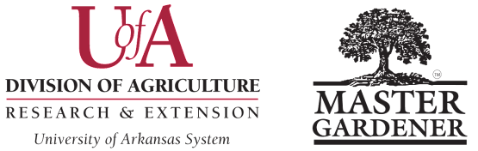

**NEWSLETTER OF THE YEAR AWARD**

**Washington County Master Gardeners**

**Submission Deadline is October 15** Please submit a digital copy in Word format to Colin Massey, [cmassey@uada.edu](mailto:cmassey@uada.edu), with “Awards Committee” in subject line.

Name of MG Contact Submitting Nomination: __________________________________________________________

MG Contact Email Address: ________________________________________________________________________

MG Contact Phone Number: ________________________________________________________________________

Newsletter Name: _________________________________________________________________________________

Newsletter Managing Editor’s Name: _________________________________________________________________

Email: ___________________________________________________Phone: _________________________________

Newsletter Editor's Name: __________________________________________________________________________

Email: ___________________________________________________Phone: _________________________________

Indicate if Editors are equal partners or if Managing Editor is leader: _________________________________________

**Guidelines:** This award is open to all Master Gardener Program newsletters EXCEPT those which have won in the last 5 years. The newsletter must be written and edited by Master Gardeners and adhere to UADA Brand Identity and Logo Standards and Guidelines, found online at the UADA website.

This award will be judged on the following four criteria:

1. Overall presentation or appearance of the publication. (25 points)

2. Content. (25 points)

3. Writing. (25 points)

4. Graphics, layout, and design. (25 points)

Submit the completed application form. Include two editions of your MG newsletter as either PDF-formatted email attachments or the weblink to online versions.

**Winning nominations** will be presented as a short video at the AR MG State Conference, then nomination material highlights may be made available on the publicly accessible AR MG website. Please have numerous action-shot images of newsletter creation/editing and other issues from the year available to enhance the video. Please note that minors and adults who have not signed photo waivers need to have their facial features blurred.

For guidance in writing effective entries see Checklist for Writing an Effective Arkansas Master Gardener Nomination.

*Revised August 1, 2024 WCMG Award Form – Page 9*