

**CHECKLIST FOR WRITING AN EFFECTIVE AWARD NOMINATION**

**Washington County Master Gardeners**

**Click on the Awards link to view winning nomination highlights, a sample nomination and judging scoresheet for guidance**: <https://www.uaex.uada.edu/yard-garden/master-gardeners/awards.aspx>

**PLAN**

1. WCMG members of WCMG sanctioned projects, committees, subcommittees, and general membership are

authorized to submit nominations in **any/all** WCMG award categories.

2. Criteria for each award is found at *wcmgar.org* website, Member Portal, Award Forms Section.

3. Start early in the year – discuss with and invite input from other members of a project/committee about

potential nominations.

4. Washington County Awards Committee requires all award nominations be submitted prior to **October 15**.

5. Digital copies of all nominations are to be emailed to Colin Massey, **cmassey@uada.edu**,

with “Awards Committee” in the subject line.

6. Give yourself time to read the nomination criteria, gather information and lots of action images, draft the

nomination, check it for errors and word counts, etc., to ensure your nomination qualifies.

**GATHER INFORMATION**

1. Make notes about contributions/achievements of individuals/teams and project(s) all year long.
2. Use statistics to track measurable results against goals.
3. Take action-oriented photos throughout the year and ID all in each photo and each person’s role. State winners need at least 40 images to make the video look good and representative of the work done.

4. Gather lots of action images or newspaper articles – images make an award nomination stronger.

5. Invite input from the potential nominee individual/team. Doing so can help create a unique story of

your nominee and provide detailed examples you may not have known.

**DRAFT DOCUMENT**

1. Think of your nomination as an investigative story record: **Who, What, When, Where** and **How**.
2. The nomination should be a stand-alone documentrather than filling in the nomination guidelines.
3. Group ideas for your nomination as outlined in the nomination criteria headings, i.e., Project Start & Evolution, Need, Goals, Hours Worked, Impacts on Intended Audiences, How Evaluated, Stats, etc.
4. Address all award criteria. Judges notice.
5. Focus on how the nomination’s contribution/achievement/skill is significant and deserving of recognition, using specific details and descriptions to show nominee’s impact.
6. Use data (number of people served, money earned, hours worked, etc.) to measure nominee’s impact against goals. Judges want to know evaluation data.
7. Use action verbs and action photosto tell the narrative. Be a storyteller. Draw the judge in.
8. Avoid using acronyms or nicknames, especially on first reference. Spell things out for those who may not know us or our state.
9. Use a standard word processing software in at least 11-point type. Microsoft Word and Google Docs have word count, spelling, and grammar features. Most judges count off for grammar mistakes.

*Revised August 3, 2024 WCMG Award Forms – Page 11*

**DRAFT DOCUMENT** *(Continued from page 5)*

1. Use our standard nomination title, so the judges see consistency across all the nominations.

**[Last Year] Arkansas Master Gardener – [Category] of the Year Nomination**

**[Nominee Name]**

**Submitted by the [Program Name] Master Gardeners [indicate (50- or 51+ members)]**

**EDIT DOCUMENT**

1. Have “fresh eyes” (i.e., other Master Gardeners) read and critique the document.
2. Check for word count to ensure it is at or under the limit. Word counts are just for the body of the nomination, not the entire nomination. Therefore, headings, subheadings, footers, page numbers, bullet points/numbered lists, and photo captions are NOT part of the word count. The above-mentioned items help the judges by chunking the nomination into parts rather than one long narrative, making it easier for the judges to read and judge.
3. Embed fully captioned images as JPEGs at the end of the nomination.

**SUBMIT EARLY**

1. Record all the necessary information on nomination (i.e., names, email addresses, phone numbers, etc.

2. Washington County Awards Committee requires all nominations forms be submitted prior to **October 15**.

3. Digital copies of all nominations are to be emailed to Colin Massey, **cmassey@uada.edu**,

with “Awards Committee” in the subject line.

*Revised August 3, 2024 WCMG Award Forms – Page 12*

**SAMPLE NOMINATION DOCUMENT**

**2022 Arkansas Master Gardener – Master Gardener of the Year Nomination**

**John Doe**

**Submitted by the Alpha County Master Gardeners**

***(Developed by County 76 RRR Committee)***

John Doe joined the Alpha County Master Gardeners in 2017, became VP in 2019 and President in 2020. John has continued to lead, motivate, and recruit for the Alpha County MGs (ACMGs) through his dedication and service to our community, ACMGs, and sanctioned projects.

Community Service and Outreach

For the past 3 years, John has represented the ACMG program at the Alpha County Extension Council Meeting, helping to raise the profile of the County Extension Services’ work within the community.

In the process of obtaining 38 cubic yards of compost donated from the City of Zeta to the ACMGs’ community garden, John shared highlights of the ACMGs’ sanctioned projects with the mayor of Zeta, Alicia Beta. As a result of this briefing, the ACMGs were awarded the Spirit of Zeta Award by Mayor Beta.

Helping Fill a Need

A shortcoming John recognized within the ACMG program was a lack of membership from smaller communities in Alpha County. In response, John suggested the ACMG Community Outreach Committee visit a different community’s Farmers Market each month to not only recruit new MGs but to raise awareness of the Alpha County Extension Service, as well as answer gardening questions. As a result of meeting 43 people at 5 different communities’ Farmers Markets, 8 people inquired about enrolling in the Master Gardener Training; 5 people completed the Spring 2022 40-hour in-person training at the Extension Office.

Sanctioned Projects Work

John’s impact on the ACMG program is best illustrated by his project participation.

This year at the Zeta Community Garden, he led the selection and planting of 12 fruit trees and organized 6 work days (a total of 27 ACMGs toiled for 337 hours to weed, mulch, deadhead, plant, water and fertilize the garden.)

For the 2022 ACMG Plant Sale, John propagated 473 plants which sold for $2,365 (these funds are shared amongst the 8 ACMG sanctioned projects); 264 people attended the 4/16/2022 plant sale. John has started more than 100 plants for the Spring 2023 Plant Sale.

John recorded 337 sanctioned project hours in 2022 with multiple ACMG projects, from greeting new MGs by name at all meetings, to serving on the mentoring committee, to working several “soil” projects.

John makes MGs at all skill levels feel welcome in the garden.

**Word Count: 366**

**Nomination title, subheadings and image captions are NOT part of the document word count.**

*Revised August 3, 2024 WCMG Award Forms – Page 13*

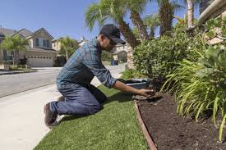

John Doe helps mulch the Zeta Community Garden’s decorative street-side bed.

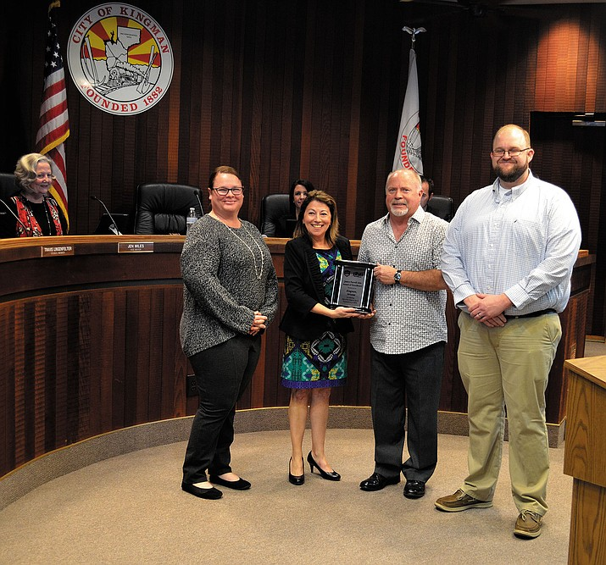

Alpha County Master Gardeners receive the Spirit of Zeta Award from Mayor Beta in the city council chambers in recognition of their many projects in Zeta, including the new Children’s Garden at the Zeta Public Library, Community Food Garden, Extension Office landscaping, Alpha County Courthouse beautification and Spring Plant Sale.

From left (L to R): City Councilwoman Cathy Delta (seated), ACMG President Ellen Faulkner, Zeta Mayor Alicia Beta, ACMG John Doe, and Alpha County Extension Agent George Hall. 10/28/2022

*Revised August 3, 2024 WCMG Award Forms – Page 14*

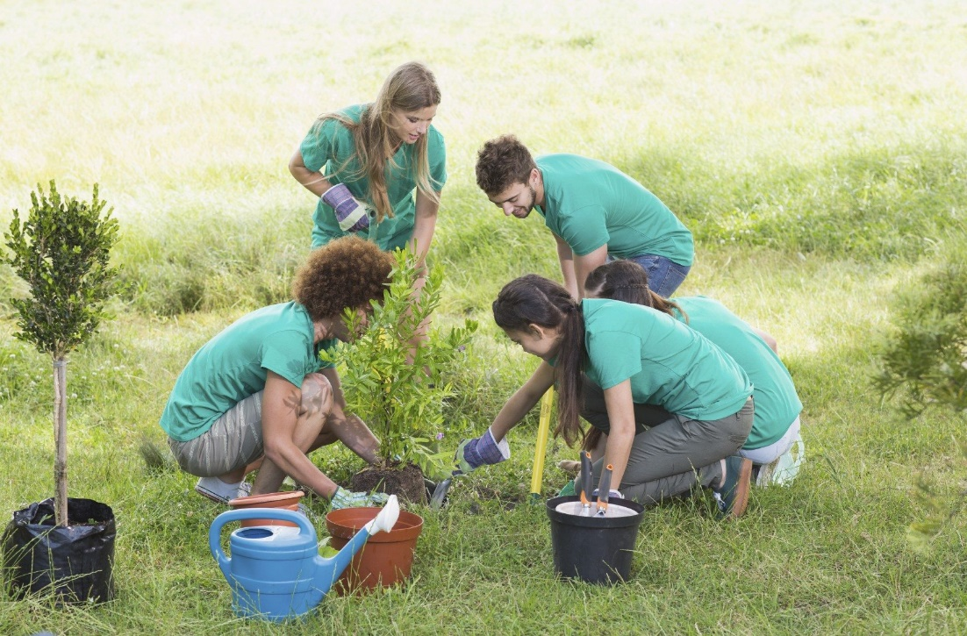

ACMGs and volunteers from Nutrition Warriors and Junior Service League plant trees in the Zeta Community Garden on 9/28/2022.

Clockwise from left: Nutrition Warrior volunteer Jackie King, Junior Service League volunteer Laura Moon, ACMG John Doe, ACMG Nancy Oliphant and Nutrition Warrior Paula Rouse.

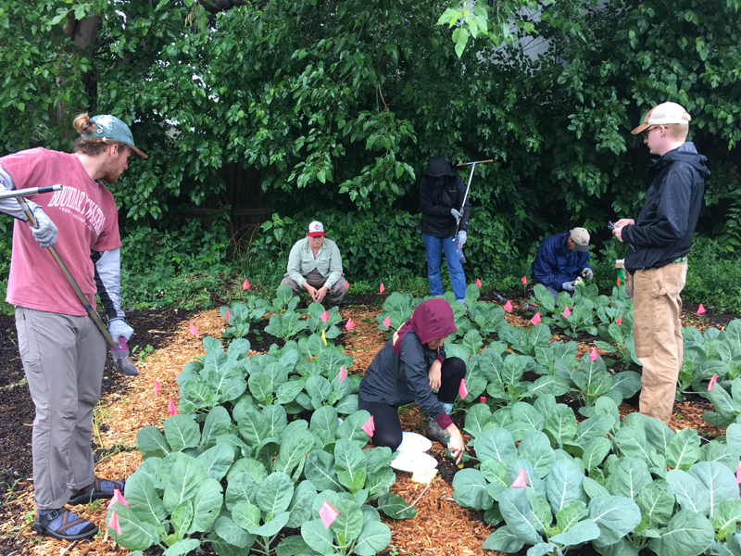

ACMG John Doe joins a work crew in the Zeta Community Garden on 11/3/2022.

(From L to R): ACMG Zeke Quarles, county probation volunteer John Party, ACMG Susan Digg (kneeling), ACMG Rebecca Lane, ACMG John Doe (kneeling) and AC Extension Agent Mark Dudley supervises.

**(Remember: Nomination title, subheadings (to break up lengthy test passages) and image captions are NOT part of the document word count.)**

*Revised August 3, 2024 WCMG Award Forms – Page 15*