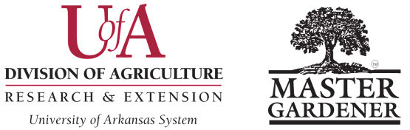
NEWSLETTER OF THE YEAR AWARD
Washington County Master Gardeners
Submission Deadline is October 15 Please submit a digital copy in Word format to Colin Massey, cmassey@uada.edu, with “Awards Committee” in subject line.

Name of MG Contact Submitting Nomination: __________________________________________________________

MG Contact Email Address: _____________________________ MG Contact Phone Number:____________________

Newsletter Name: _________________________________________________________________________________

Newsletter Distribution Frequency: ___________________ How Distributed: _________________________________

Audience(s): _____________________________________________________________________________________

Newsletter Managing Editor’s Name: __________________________________________________________________
Email: ___________________________________________________Phone: __________________________________
Newsletter Editor's Name: ___________________________________________________________________________
Email: _______________________________________________________Phone: _____________________________
Indicate if Editors are equal partners or if Managing Editor is leader: _________________________________________

Guidelines: This award is open to all Master Gardener Program newsletters EXCEPT those which have won in the last 5 years. The newsletter must be written and edited by Master Gardeners and adhere to UADA Brand Identity and Logo Standards and Guidelines, found online at the UADA website. This award will be judged on the following four criteria:
- Overall presentation or appearance of the publication. (25 points)
- Content. (25 points)
- Writing. (25 points)
- Graphics, layout, and design. (25 points)
Submit the completed application form. Include two editions of your MG newsletter as either PDF-formatted email attachments or the weblink to online versions. Indicate your:
- Newsletter Name
- Distribution Frequency.
- Distribution Method(s), i.e., printed copies, via email link, via local MG website, etc.
- Audience(s).
- Regular Features.
- Who submits content (Staffers? Regular Contributors? Any MG?)
- How Content is Edited and Proofed.
- MG Program Size (number of active members (who report online hours) and number of total members on the rolls.
Winning nominations will be presented as a short video at the AR MG State Conference, then nomination material highlights may be made available on the publicly accessible AR MG website. Please have numerous images of newsletter creation/editing and other issues from the year available to enhance the video. Please note that parent/guardian-signed UADA media release forms are required for minors; if these forms are not on file, blur their facial features.

For guidance in writing effective entries see Checklist for Writing an Effective Arkansas Master Gardener Nomination.
Revised August 22, 2025 WCMG Award Form – Page 10

