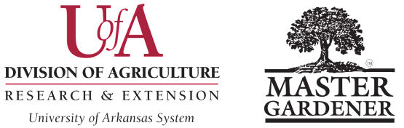

FRIEND OF WCMG AWARD Business or Organization Category
Washington County Master Gardeners
Submission Deadline is October 15 Please submit a digital copy in Word format to Colin Massey, cmassey@uada.edu, with “Awards Committee” in subject line.
Name of MG Contact Submitting Nomination: ___________________________________________________________
MG Contact Email: ____________________________________________Phone: _______________________________
Business or Organization Name: _______________________________________________________________________
Business or Organization Contact Name: ________________________________________________________________
Email Address for Contact: __________________________________________________________________________
Phone Number for Contact: ___________________________________________________________________________
Business or Organization Mailing Address: ______________________________________________________________

City: ___________________________________________________________ Zip Code: ________________________
Guidelines: This award is open to a non-Extension or non-Master Gardener business or organization which has shown outstanding support of the Master Gardener Program in your county EXCEPT those who have won in the last 5 years.
The nomination must not exceed 500 words. (Note that required nomination title, subheadings (to break up lengthy text passages) and image captions are NOT part of the document word count.) Please submit the following information:

- Give a description of how the business or organization has supported the MG program in your county/program area. Place all the requested data under the subhead How [business or organization] supported the [MG program name]. (45 points)

- Explain the business or organization’s impact on the MG program, Extension Service, and the county. Be sure to include objectives and goals, as well as how the business or organization’s impact was evaluated. Cite measurable data. Place all the requested data under the subhead [Business or organization’s] impacts on our MG program, Extension Service, and the county. (45 points)

- Submit 5 high-resolution action-oriented digital images in JPEG format embedded at the end of your nomination; one of the images should be a close-up of a few individuals interacting (not all group shots). Identify via captions who is in the image, the project name and site, and MG work being performed. Images should provide support, clarify and enhance the understanding of the nomination narrative. Digital images may include photographs, garden planning/layout sketches or maps, newspaper clippings, etc. (10 points)
Winning nominations will be presented as a short video at the AR MG State Conference, then nomination material highlights may be made available on the publicly accessible AR MG website. Please have numerous additional images for the video and website posting. Please note that parent/guardian-signed UADA permission slips are required for minors; if permission slips are not on file, blur their facial features.
For guidance in writing effective entries (based in large part on judges’ comments), see Checklist for Writing an Effective Arkansas Master Gardener Nomination.
Revised August 22, 2025 WCMG Award Form – Page 4

