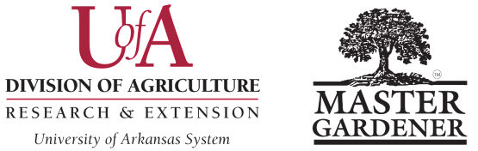

FRIEND OF WCMG AWARD Individual Category
Washington County Master Gardeners
Submission Deadline is October 15 Please submit a digital copy in Word format to Colin Massey, cmassey@uada.edu, with “Awards Committee” in subject line.
Name of MG Contact Submitting Nomination: ___________________________________________________________
MG Contact Email Address: __________________________________________________________________________
MG Contact Phone Number: __________________________________________________________________________
Nominee Name: ____________________________________________________________________________________
Nominee Email Address: _______________________________Nominee Phone Number: _________________________
Nominee Mailing Address: ___________________________________________________________________________
City: _______________________________________________________ Zip Code: ____________________________
Guidelines: This award is open to a non-Master Gardener individual who has shown outstanding support of the Master Gardener Program in your county EXCEPT those who have won in the last 5 years.

The nomination must not exceed 500 words. (Note that required nomination title, subheadings (to break up lengthy text passages) and image captions are NOT part of the document word count.) Please submit the following information:

- Give a description of how the nominee has supported the MG program in your county. Place all the requested data under the subhead How [Name] supported the [MG program name]. (45 points)

- Explain the nominee’s impact on the MG program, the Extension Service, and the community. Be sure to include how the individual’s impact was evaluated. Cite measurable data. Place all the requested data under the subhead [Name’s] impacts on our MG program, Extension Service, and the county. (45 points)

- Submit 5 high-resolution action-oriented digital images in JPEG format embedded at the end of your nomination; one of the images should be a close-up of the friend interacting with a small group (not all group shots). Identify via captions who is in the image, the project name and site, and MG work being performed. Images should provide support, clarify and enhance the understanding of the nomination narrative. Digital images may include photographs, garden planning/layout sketches, newspaper clippings, etc. (10 points)

Winning nominations will be presented as a short video at the AR MG State Conference, then nomination material highlights may be made available on the publicly accessible AR MG website. Please have numerous additional images, including a head shot, available for the video. Please note that parent/guardian-signed UADA media release forms are required for minors; if permission slips are not on file, blur their facial features.
For guidance in writing effective entries (based in large part on judges’ comments), see Checklist for Writing an Effective Arkansas Master Gardener Nomination.
Revised August 31, 2025 WCMG Award Form – Page 5

