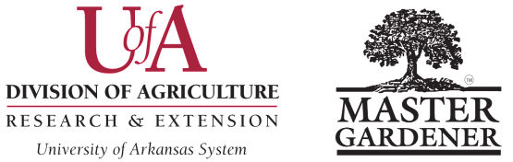
MIMI COX MENTOR OF THE YEAR AWARD
Washington County Master Gardeners
Submission Deadline is October 15

Please submit a digital copy in Word format to Colin Massey, cmassey@uada.edu, with “Awards Committee” in subject line.

Name of MG Contact Submitting Nomination: ___________________________________________________________

MG Contact Email Address: _________________________________ MG Contact Phone Number: _________________

Nominee Name: ____________________________________________________________________________________

Nominee Email Address: ________________________________ Nominee Phone Number: _______________________
Year Nominee became a Master Gardener: ______________Total Qualified Length of Service Years: _______________

Guidelines. The Mimi Cox Mentor of the Year Award recognizes a Master Gardener who has worked directly with one or more Master Gardener mentees/graduates during their first year in the local county program and/or has made significant contributions to the county’s mentoring program. All active Master Gardeners are eligible to be nominated EXCEPT previous winners.

The nomination must not exceed 800 words. (Note that required nomination title, subheadings (to break up lengthy text passages) and image captions are NOT part of the document word count.)
Please submit the following information:
- Give a description of the exceptional skills at providing the mentees/graduates a welcoming, supportive environment, in which to thrive and grow as a Master Gardener, or by providing exceptional guidance and contributions to the county’s mentoring program. Identify the nominee’s participation in activities, sanctioned and non-sanctioned projects, committee work, total number of work hours and total number of education hours, etc. Place all the required data under the subhead How [Name] welcomes, supports, and motivates Master Gardeners and helps them thrive and grow. (45 points)

- Explain how the nominee’s actions impacted the mentees, the MG program, and the Extension Service. Be sure to include how the nominee’s impact was measured and evaluated. Place all the required data under the subhead [Name’s] impacts on new Master Gardeners, Extension Service, and our community. (45 points)

- Submit 5 high-resolution action-oriented digital images JPEG format embedded at the end of your nomination; one of the images should be a close-up of the MG interacting with individuals or small groups (not all group shots). Identify via captions who is in the image, the project name and site, and MG work being performed. Images should provide support, clarify and enhance the understanding of the nomination narrative. Digital images may include photographs, garden planning/layout sketches, newspaper clippings, etc. (10 points)

Winning nominations will be presented as a short video at the AR MG State Conference, then nomination material highlights may be made available on the publicly accessible AR MG website. Please have numerous additional images, including a head shot, available for the video and website posting. Please note that parent/guardian-signed UADA media release forms are required for minors; if these forms are not on file, blur their facial features.

For guidance in writing effective entries (based in large part on judges’ comments), see Checklist for Writing an Effective Arkansas Master Gardener Nomination.

Revised August 22, 2025 WCMG Award Form – Page 9

